SOP for Create a Service Request Tickets
Purpose
To log and track customer service requests, hardware issues, field engineer visits, and managed service activities in the Cache Portal.

Step 1: Navigate to Ticket Creation
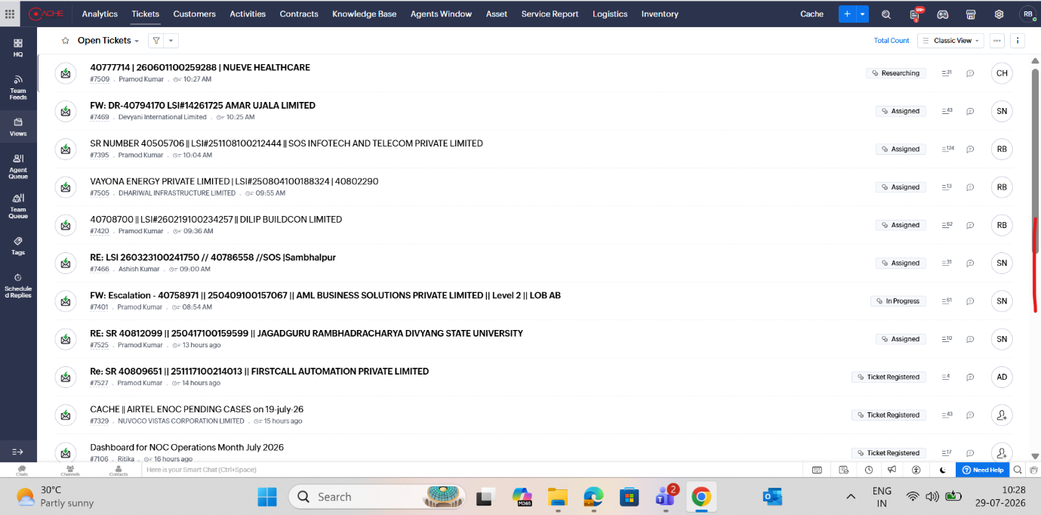

- Login to the Cache Portal.
- Go to Tickets.
- Click Add Service Request Ticket.
- Select the appropriate Service Request Ticket Template.

Step 2: Fill Basic Information
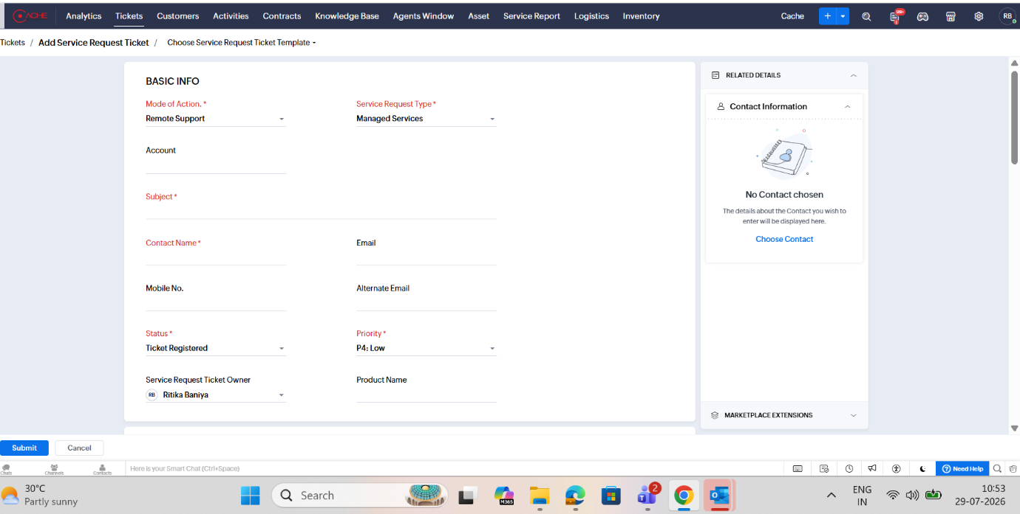

Mandatory Fields (*)
Field | Description
Mode of Action* | Select Remote Support / Onsite Support
Service Request Type* | Select appropriate service category (e.g., Managed Services)
Subject* | Brief description of the issue/request
Contact Name* | Customer contact person
Status* | Default: Ticket Registered
Priority* | Select P1/P2/P3/P4 as applicable
Additional Details
- Account
- Email
- Mobile Number
- Alternate Email
- Service Request Ticket Owner
- Product Name

Step 3: Select Contact Information
- Click Choose Contact from the right panel.
- Select the customer contact.
- Verify:
  - Contact Name
  - Email
  - Phone Number

Step 4: Enter Asset Details
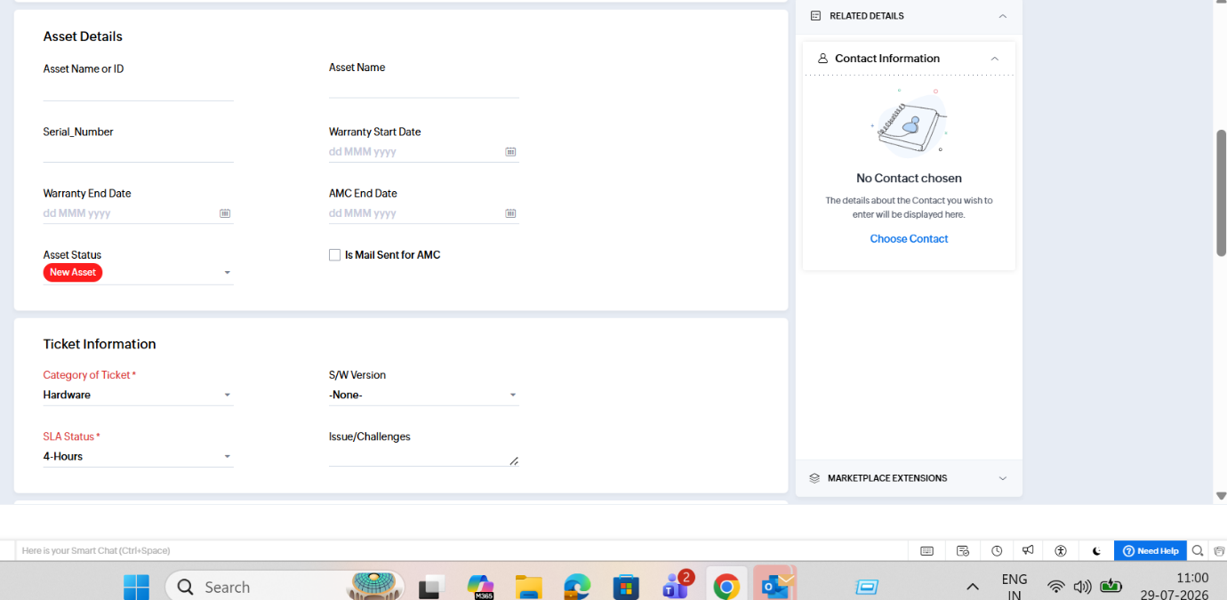

Fill the available asset information:
Field | Details
Asset Name or ID | Asset identifier
Asset Name | Device name
Serial Number | Hardware serial number
Warranty Start Date | Start of warranty
Warranty End Date | Expiry of warranty
AMC End Date | AMC validity
Asset Status | New Asset / Existing Asset
Is Mail Sent for AMC | Check if AMC mail sent

Step 5: Enter Ticket Information
Mandatory Fields
Field | Description
Category of Ticket* | Hardware / Software / Network
SLA Status* | Select applicable SLA
Additional Fields
- S/W Version
- Issue / Challenges description

Step 6: Enter Ticket Reference Details
If available, fill:
- Service Request Number
- End Customer Reference / LSI

Step 7: Enter End Customer Site Details
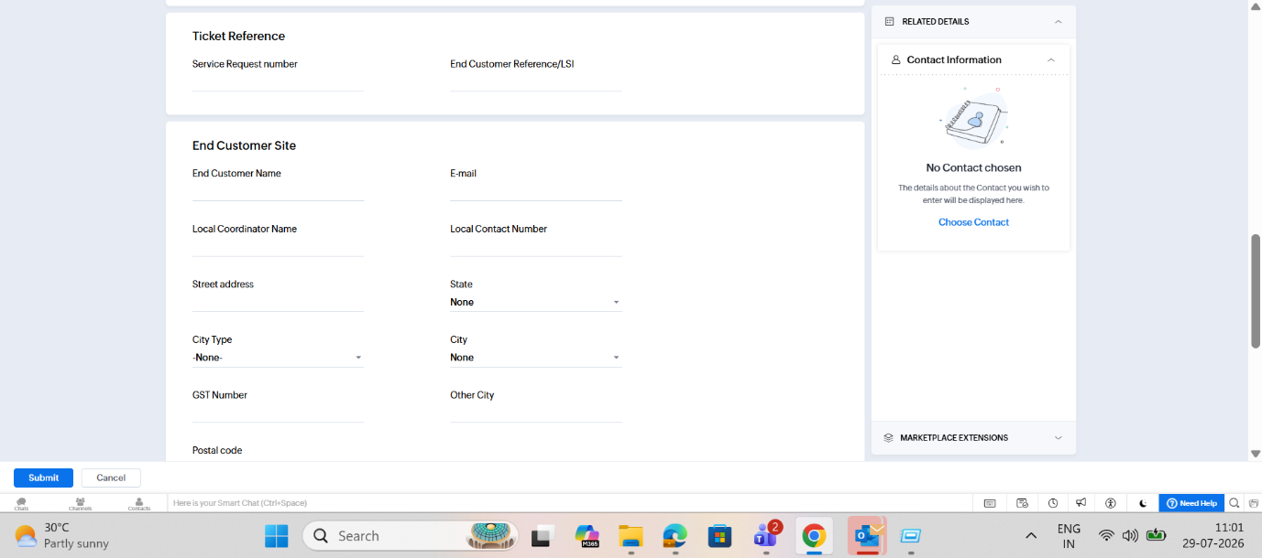

Provide customer location information:
Field | Details
End Customer Name
E-mail
Local Coordinator Name
Local Contact Number
Street Address
State
City Type
City
GST Number
Other City
Postal Code

Step 8: Fill Additional Information
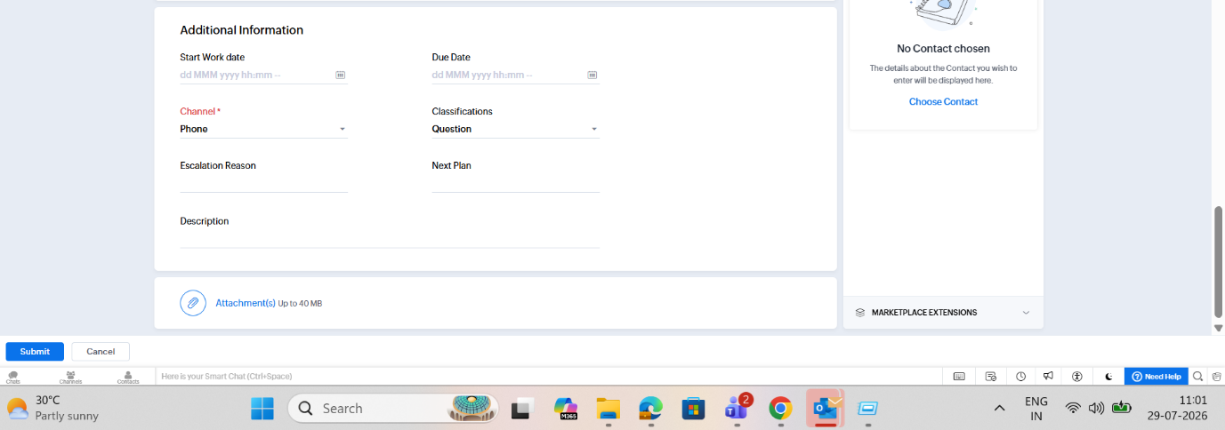

Field | Description
Start Work Date | Ticket start date and time
Due Date | Expected closure date
Channel* | Phone / Email / Portal
Classifications | Question / Incident / Service Request
Escalation Reason | If applicable
Next Plan | Next action
Description | Detailed issue description

Step 9: Upload Attachments


- Click Attachment(s).
- Upload supporting files.
- Maximum file size: 40 MB.
Examples:
- Error screenshots
- Logs
- Customer emails
- Device photos

Step 10: Field Engineer Visit Details (If Onsite Support Required)
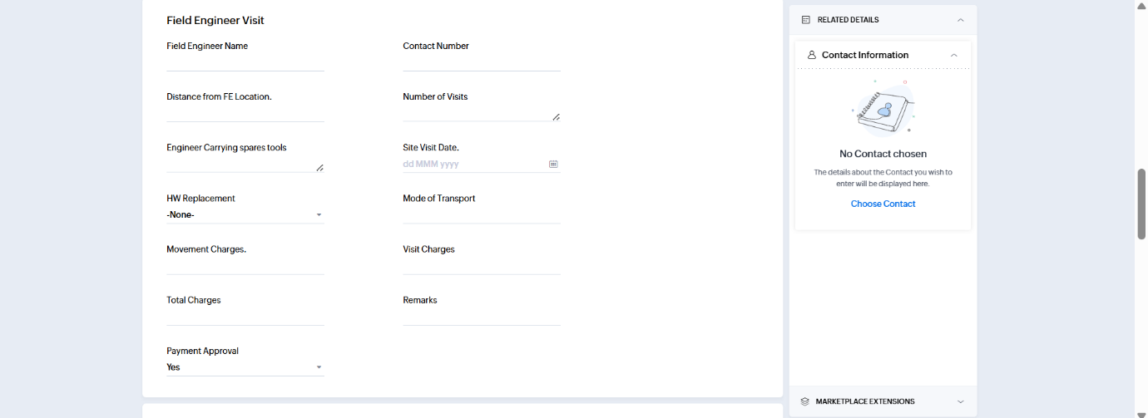

Fill the following details:
Field | Description
Field Engineer Name
Contact Number
Distance from FE Location
Number of Visits
Engineer Carrying Spares Tools
Site Visit Date
HW Replacement
Mode of Transport
Movement Charges
Visit Charges
Total Charges
Remarks
Payment Approval

Step 9: OEM Support Details (If OEM Case Raised)
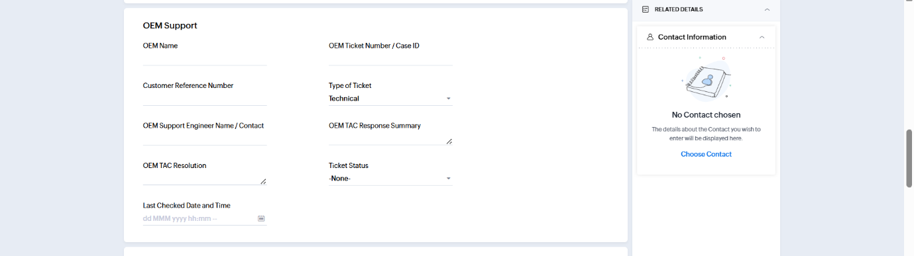

If the issue requires escalation to the Original Equipment Manufacturer (OEM) or Technical Assistance Center (TAC), complete the OEM Support section.
OEM Support Fields
Field | Description
OEM Name | Name of the OEM vendor (e.g., Fortinet, Cisco, Aruba, Dell, HP, Sophos)
OEM Ticket Number / Case ID | OEM-generated case number or ticket reference
Customer Reference Number | Customer-provided reference related to the OEM case
Type of Ticket | Select Technical / RMA / Configuration / Hardware / Software as applicable
OEM Support Engineer Name / Contact | Name and contact details of the OEM support engineer handling the case
OEM TAC Response Summary | Summary of troubleshooting steps or recommendations provided by OEM TAC
OEM TAC Resolution | Resolution provided by the OEM team
Ticket Status | Current OEM ticket status (Open / Pending Customer / Pending OEM / Monitoring / Resolved / Closed)
Last Checked Date and Time | Date and time when the OEM case was last reviewed or updated
Step 11: Review and Submit
Before submitting, verify:
✅ Subject is clear and meaningful
✅ Contact details are correct
✅ Asset details are accurate
✅ SLA selected correctly
✅ Issue description is detailed
✅ Attachments uploaded (if required)
✅ FE details updated (for onsite visits)
Click Submit to create the ticket.

